WAGE DETERMINATION OF TECHNICALLY SKILLED WORKERS IN THE INFORMAL SECTOR

Dissertation Submitted to St. Joseph’s College Of Arts And Science
(Autonomous)


For The Award of Masters Degree in Economics
By
NIKHIL MUTHUKRISHNAN
12ECO5311

Dissertation Guide
Dr.Manojit Bhattarcharjee
Department of Economics
(Post Graduate and Research Centre)
Lalbagh road, Bangalore-560027
2013-14

Declaration

I, hereby declare that the dissertation entitled “Wage Determination of Technically Skilled Workers in the Informal Sector” incorporates the results of my independent research under the supervision of Dr.Manojith Bhattarcharjee Post Graduate Department of Economics, St. Joseph’s College. I further declare that it has been not been previously submitted in part or in full to this or to any other University for any degree or diploma. Due acknowledgments have been made wherever matter has been cited from other sources.

Nikhil Muthukrishnan
St.Joseph`s College(Autonomous)
Bangalore- 560027
Date:
Place:

Guide’s Declaration

This is to certify that the thesis entitled Wage Determination of Technically Skilled Workers in the Informal Sector” submitted by Nikhil Muthukrishnan in fulfillment of the requirements for the award of Post Graduate Degree in Economics is an original work. I certify that this has not been submitted in part or in full to any university for the award of any degree or diploma.

Research Guide
Dr.Manojit Bhattarcharjee

Date:
Place ;

Acknowledgement
The research work would not have been possible without the guidance and help of several individuals who in one way or another contributed and extended their valuable assistance in the preparation and completion of this study. I express my heartfelt gratitude to them. Among them are:
Dr. Manojit Bhattarcharjee for his expert help with econometric analysis without which this thesis would not have had the quantitative dimension that it has now. His knowledge of the subject of economics is amazing and very thorough. The simplicity and clarity of his guidance ensured that I learnt econometrics well enough to apply it again for future use. Thank You Sir It was an honour to work under your guidance.
Dr.Subhashini Muthukrishnan for her experience without which I would have been groping in the dark for solutions to my research problem. Her sheer experience with guiding students allows her to identify exactly what problems a struggling fresh researcher faces and she provided the opportunity to be acquainted with research at a much earlier stage than most students around the country.
To Dr.Ayenendu Sanyal for pointing out the flaws in my econometric analysis without which I might have arrived at wrong conclusions.
Dr Lalith Achot for his dedication to helping students into the night without a break. His ability to grasp the myriad of research problems students have and simplify it for students shows his experience but most of all I admire his perseverance and wish to emulate that quality.
Dr.Fr Daniel Fernandes, SJ former principal and Fr Praveen Martis, S.J. Principal for granting me admission to this prestigious institution without which this research work would not have been possible. His principality is just and progressive.
To respondents for sharing their life’s story with me I hope I will be able to make a change for them and their families with the help of my future research.
Friends and classmates specially Arvind for helping me collect data from all over Bangalore .His aid was very necessary to finish this research on time.
My sister for proof reading my entire thesis and correcting mistakes I oversaw. My father for helping me collect my initial data and giving me the kick-start this project .My mother, for being my Teacher and my Guide without whose support his would not have seen the light of the day.

 | TABLE OF CONTENTS
 |  | Page no
CHAPTER I : Introduction to Research Methodology |  | 8
1.1 | Statement of the Problem. | 8
1.2. | Introduction to Informal Labour in India | 9
1.3. | Introduction to Manufacturing Sector In India | 10
1.4. | Brief Review of Literature | 10
1.5. | Research Issue | 11
1.6. | Research Gaps | 11
1.7. | Need for the study | 12
1.8. | Research Objectives | 12
1.9 | Hypotheses | 12
1.1 | Scope of the Study | 13
1.11 | Value of the study | 13
1.12 | Research Design and Methodology | 13
1.13 | Important Variables | 14
1.14 | Chapter Scheme | 15
1.15 | Limitations Of The Study | 15
Chapter II: Review of Literature
2.1 | Theoretical Literature Review. | 16
2.2 | Empirical Literature Review. | 18
2.3 | Conclusion and Discussion. | 21
CHAPTER III: INFORMAL SECTOR IN INDIA
3.1 | Informal Sector | 23
3.2 | Skill Development in India | 25
3.3 | Skill Development programs of Government of India | 29
3.4 | Skill Development programs of Government of Karnataka | 29
3.5 | Karnataka industry Overview | 30
3.6 | Conclusion | 31
CHAPTER IV: AN EMPIRICAL ANALYSIS OF WAGE DETERMINATION OF TECHNICALLY SKILLED WORKERS IN THE INFORMAL SECTOR
4.1 | Introduction. | 33
4.2 | Data Source. | 34
4.3 | Empirical Results. | 35
4.4 | Econometric Results. | 45
4.5 | Conclusion and Discussion
CHAPTER V: SUMMARY , CONCLUSION AND POLICY IMPLICATIONS
5.1 | A Summary of Findings of the Study. | 47
5.2 | Conclusion | 47
5.3 | Policy Implications. | 48
 | References | 49
 | Annexure-I | 50
 | Annexure-II | 54

CHAPTER I
INTRODUCTION TO RESEARCH METHODOLOGY

  - Statement Of The Problem

The informal sector which employs a large number of people is usually related to characteristics of workers who work in precarious labour market conditions which include lack of access to labour protection and social cover and hence have low quality of employment. The levels of skills required for employment in this sector is low and often acquired while on the job. The shortfall in skill arise from the fact that it is most often due to low education of prospective workers, unequal access to training, underdeveloped markets, lack of attention by public training providers, and market constraints affecting small and household enterprises. A large number of the workforce in India and in several other developing countries is engaged for work in this informal sector.

Training and skill development in India is provided formally by an ITI or Diploma college and from training while on the job, often called on the job training (OJT). This training is often combined with work as the instructions are very simple. This OJT however encourages on the job informal training for different skills in the labour market as well. The problem with informal training without certification is that it excludes labourers from seeking formal employment. Informal workers are given low wages and no security benefits. This has undesirable labour market outcomes such as poverty, and low levels of Human development.

This nature of employment raises concern over their wages and skill development which requires an examination. Therefore, understanding the links between informal employment and skill development and identifying the factors which determine wages is of important. To absorb more workers in the formal sector studies and for formulating policy, research must be done on the skill formation that happens in the informal labour market.

1.2. Introduction to Informal Labour in India
In most developing countries there is a large sector of the economy that is called the informal sector or the unorganised sector. Employment in the informal labour market plays an important role in most developing economies. Very broadly, the informal labour market consists of workers in the informal sector plus casual workers in the formal sector. The informal labour market is a large part of the agricultural sector, but is also a significant part of the urban sector. There is a difference between employment in the formal sector and the informal sector in terms of the conditions of work, whether workers are subject to government taxes, have access to social security or insurance, casual or contract workers, whether they receive minimum wages or not.

The informal economy is a very important sector of the Indian economy: the National Council of Applied Economic Research estimates that the informal sector -“unorganised sector”- generates about 62 % of GDP, 50 % of national savings and 40 % of national exports, (ILO 2002, p. 30). In terms of employment, the informal economy provides for about 55 % of total employment (ILO 2002, p. 14). Urban areas (especially large cities) attract numerous migrants from both the rural areas and from smaller urban towns and cities in the hope of a better life.

The National Commission for Employment in the Unorganized Sector (NCEUS) defined “The informal sector consists of all unincorporated private enterprises owned by individuals or households engaged in the sale and production of goods and services operated on a proprietary or partnership basis and with less than ten total workers.”

The Indian labour market can be conceived of as a segmented market: a formal sector with workers who have salaried work, with good working conditions, and of course organised business. The informal economy would consist of small self-employed traders and business people, and casual workers in the informal or formal sectors.

  - Introduction to Manufacturing Sector In India
India has become one of the fastest growing economies in the world over the last two decades, undoubtedly aided in this performance by economic reforms. The striking aspect of India’s recent growth has been the dynamism of the service sector, while, in contrast, manufacturing has been less robust. The Manufacturing sector’s contribution to the GDP has stagnated at 16%, raising questions about India’s development model, including its sustainability, especially for generating adequate employment. Currently, India’s manufacturing sector contributes about 16% to the GDP, and India’s share in world manufacturing is only 1.8%. This is in stark contrast to China; where manufacturing contributes 34% to the GDP and is 13.7% of world manufacturing – up from 2.9% in 1991.

India’s growth has been on the back of a booming services sector which contributes 62.5% of the GDP. These statistics clearly indicate that while manufacturing has not been the engine of growth for the Indian economy, it now needs to grow at a much faster rate. With changing global realities, the manufacturing sector will need to be the bulwark of employment creation over the next decade, in contrast to current employment of only 9% of India’s working population. India’s long touted demographic dividend can only then be sufficiently exploited through the systematic growth of this sector.
The lacklustre growth of manufacturing can also be traced to the low technological depth of the Indian manufacturing sector. In India R&D has not been sufficiently exploited and needs in terms of its focus and its organization. Most Indian manufacturing firms appear to be stuck at the basic or intermediate level of technological capabilities. Creating conducive environments to increase business expenditure on R&D complemented by institutional measures around skill development, regulation and standardisation need to be key areas of emphasis..

1.4. Brief Review of Literature
Skill development has emerged as a subject of national importance due to India’s demographic dividend. A brief review of literature is presented here though a detailed review of literature of literature is presented in the second chapter. The literature highlights the research issues and the gap necessary to pursue the study further. These are few of the empirical literature available. Reading has been done on informal labour in India from various articles and reports from organization and scholars. The papers written in India such as have mostly dealt with secondary data collected by the National Sample Survey Organization of India (NSSO).The articles deal with applying econometric analysis and simpler statistical tools to the given data to arrive at conclusions such as growth rate of informal labour employment in various sectors over time and share of informal labour sector wise and sex wise. The study of does include relevant variables such as caste, language and age, which are the same variables the recent research has also accounted for.

1.5. Research Issues
Informal economy and working of the informal labour markets is common to almost all developing countries. Studies have highlighted the wage differentials between workers in formal and informal sector .Most of the studies have used study secondary data and have found wage differences between formal and informal sector. Analysis has used both simple statistical tools and econometric models.

1.6. Research Gaps
Extensive reading has been done in the area of informal labour in India and in some of the countries of the world. These research studies have provided macro insights into the working of the labour market. In the past empirical evidence had been collected to highlight potential macro economic implications of informal economy such as share of informal sector revenue to GDP, growth of informal workers over the past decade, industry wise distribution of informal workers and their growth rates. However these studies have not examined the wage differences between formal and informal employment with technical skills which are acquired by formal certification and by on the job training especially in the context of India and technical skills .There is a need to examine this issue by examining primary data. More over received literature does not suggest such studies have been conducted in Bangalore.

1.7. Need for the study
To increase the manufacturing productivity in India several issues must be addressed such as low investment in Research & Development ,low technology and most importantly low level skill development in the highly skill intensive sector. The research is being done to highlight the issues regarding the low level of skill development in India and its impact on wages. This is due to several factors such as low education, lack of incentive to join formal trade, no certification for skill and a large number of informal industries which have a low labour capital ratio using more labour that requires lesser technical knowledge. The skill development that takes place in the informal labour market is often by on the job training and does not provide workers with any certification that can be used by them to seek other employment. There is a need to study this aspect of skill development in India’s informal sector as it will throw light on the reasons for this process of skill formation within the area of education and its effect on wages when workers are engaged in the informal sector. Thus this is not a strictly hypothesis testing study but merely exploring the dynamics of the vast market of informal labourers.

1.8. Research Objectives
This research has the following objectives:
1. To examine the nature and extent of employment in the informal sector ie. examining the nature of labour in terms of wages, work experience and skill development in the formal and informal manufacturing sector in Bangalore .
2. To identify factors that determine wages in the technical trade in the informal sector.

1.9. Hypotheses
Ho: There is no wage difference among informal technically skilled workers on the basis of Educational Qualification
H1: There is wage difference among informal technically skilled workers on the basis of Educational Qualification

1.10. Scope of the Study
The area of focus of this study pertains to the informal and formal labour population of Bangalore engaged in industrial technical trades. The study is conducted from a micro economic perspective confined to the industrial layouts in and around Bangalore such as Peenya, Mahadevpura and Cottonpet. Due to the diverse area of work such industries perform a perfect stratified sample was unavailable which is also the limitation of the study but to makeup for the uniformity samples were taken from completely unrelated areas of work such as lead lining industries, steel metal press manufacturing, printing and binding, automobile mechanics, tools and dye makers.

1.11. Value of the study
The importance of the study is that it provides a valuable source of information to the government, academicians and individuals labourers about technical skill development required in the manufacturing sector and also the importance of certification of technical skills. It also highlights the low wages and quality of work in the informal sector.

1.12. Research Design and Methodology
This study is exploratory in nature as the subject is used principally to gain a deeper understanding and description of the dynamics of skill development wages a certification in the context of formal an informal economy. In this sense it refers to inferential statistics to determine cause and effect. It aims to understand the factors that affect wages of industrial workers in Bangalore and very importantly highlight the patterns of said variables which should be included for further studies for skill development.
Data collection
Primary data was used to obtain the information on the labor force engaged in the manufacturing sector both in the formal and informal sector in Bangalore city. The information was collected using a scheduled interview through a random sample of 100 respondents from Bangalore urban, Bangalore semi urban and Bangalore rural industrial estates. The questionnaire was pretested to check for inaccuracies .The secondary data was collected from sources such as the National skill development authority, labour bureau, Planning commission and other scholarly articles.

Tools of analysis
The study analyses data using econometric tools namely ordinary least squared regression using Statistical package for social sciences to identify wage determination. Besides it used descriptive statistics to show the relationship between different variables by creating cross tabulations. Appropriate presentation of the findings is done using charts, tables and flow charts imported from Microsoft excel.

1.13. Important variables
The study has identified the following variables for analysis:
Wages: this is the dependent variables regressing all other collected variables on wages to identify the most significant influence of these variables on wages. The wages used are current wages as replied by the workers and the supervisor. Wages have also been collected of their previous employment to determine the growth of these wages.

Age: age is an important variable in economics which influences several other variables and hence it is used in this study as well.
Years of work: is an important variable as regression analysis is used to check the significance of work experience on wages. It was calculated using the employment history of the worker such number of job changed and tenure in each job.
Educational level: the education level has been divided into 3 groups for the regression analysis ie. Vocationally trained, SSLC and PUC and SSLC and SSLC and below.
Nature of trade: as the firms in the sample have large number of casual labourers who are given on the job training, they are skilled in various jobs around the factory and are known as “helpers” which is the majority of the population. Other positions on the shop floor include welder, machinists, turners, fitters and other trades.
Nativity: the place of birth is important as it denotes the migratory status of workers whether they are from the state, outside the state or are localities originating from Bangalore urban or rural. Analyses can be done on the wage differential between migrants of the 3 classes.
Nature of school (government or private): This variable identifies workers educational background and whether they have studied in government school, private schools or have qualified from vocational schools.
No of jobs changed: the respondents have replied years spent in the trade they are currently engaged in. It provides a crude work history.
Weather inclined to entrepreneurship: this question was asked in the end to see if workers are willing or interested in starting new businesses. This was a sensitive question as many workers had never been asked this. The response was slightly ambiguous but inferences can be made from this variable.

1.14. Chapter Scheme
- Introduction to research methodology. This chapter presents the various steps in research and the tools used to carry out research.
- Review of literature. This chapter has reviewed previous studies on the subject to provide insights into the present study.
- Informal sector in India. It is the background chapter indicating the nature and extent of informal labour market in India
- An empirical analysis of wage determination in technical trade is the empirical chapter which is based on the analysis of the primary data collected for this research.
- Summary, conclusion and policy implications.

1.15. Limitations of the study
As this sector is highly unorganized it is very difficult for government, potential employers and past employers to track the employment history of workers to better ascertain the wages deserved and tenure in firms. This data is crucial to measure skill development in India. Data collection for this group of informal workers with technical skills was a challenge. And the sample size is small.

CHAPTER II

REVIEW OF LITERATURE

This chapter presents a detailed review of literature. Economists of the human capital school have emphasized on the part played by education and training on human beings in the generation of income and wealth. This chapter begins with a brief review of theoretical literature on human capital and followed by empirical literature.

2.1.Theoretical Review
According to OECD (2001) human capital is the knowledge, skills, competencies and attributes embodied in individuals that facilitate the creation of personal, social and economic well being. The original human capital theory is associated with Schultz’s (1961). Schultz stated that people acquire useful skills and knowledge by making investment in themselves by paying for their education and training. He stated that education and on- the-job training generally provided by the firm make workers more skilled.
Becker (1962) developed the theory of investment in on- the job – training. He showed that investing in training increases earnings, employment and mobility of workers. Investing in training also involves an opportunity cost as workers do not earn or earn less during periods of training.
Beckers theory was supported by the earlier study on Economics of Training by Mincer in 1958 when he studied the effect of labour market experience or on the- job training on the determination and distribution of earnings. Mincer described on- the- job training as the opportunity to learn from experience that involves an investment and return. This is called the ‘Mincerian Earnings Function’. According to Mincer, (1974 ) one worker may earn more than another in the labour market because he is more highly skilled or educated while workers with certain skills will be paid higher wages than others with minimum or no skills within the same firm simple because their skills are translated into higher marginal productivity. Moreover higher wages are paid to workers found in jobs with unattractive job attributes such as monotony or high probability of accident occurrence in order to offset those attributes. However this theory cannot explain the segmented labour market dynamics.
The theory of labour market segmentation by Doreigner and Piore (1971) can explain the dynamics of why there is difference in income even with same level of education and training .

The theory of segmented labour markets (SLM) has been identified with a group of economists who challenged the classical explanation of the workings of the labour market and argued that both the neo-classical and classical treatment leave unexplained many major labour market policy issues such as the dispersion of wages and as a result income distribution , unemployment and discrimination. Insisting upon the fragmented nature of labour markets and the importance of institutional social influences upon pay and employment, the segmentations approach shifts the emphasis away from the supply side of the labour market and places the focus on the demand side. In particular, neo classical labour economics consists of the marginal productivity theory of demand based on utility maximization of by workers. The labour supply theory, in turn emphasizes issues related to labour supply. The wage structure is taken as given, differentiated by worker attributes. Moreover endogenous changes in tastes of individuals and details of the institutional framework of markets are largely ignored.
The other explanation can be given from the dual labour market theory. Traditional dual labour market maintains that jobs can be roughly divided into two groups: those with low wages, bad working conditions, unstable employment and little opportunity for advancement; and those with relatively high wages, good working conditions and opportunities for advancement. Capitalist mode of production, the process of urban-industrial change has assumed a sufficiently distinct character in each of these cities as to render problematic efforts to assimilate the explanation of such micro contextual phenomena as wage earning and self-employment to macro theories of political economy. Thus this study examines wage determination of workers who have technical skills acquired through on the job training , one which has been certified and the other not certified and who are employed in the formal and informal sector .
From this we now present an overview of empirical literature.

2.2.Empirical reviews
Reading has been done on informal labour in India from various articles and reports from organizations and scholars.

Leontardi,1998 attempts to draw a distinction between neo-classical model of labour supply and segmented labour market theory. The neo-classical model assumed that labour has a variety of options to choose for employment based on their tastes, preferences and human capital endowments. However segmented labour market theory states that there are several institutional which prove to act as barriers to entry in the formal labour market.

The study examines the attitudes and behaviours of informal workers, and explores the aspects of working informally that are appealing and may discourage people from taking steps to formalize their enterprises. The study focuses specifically on the experiences of African Americans operating informal businesses or working informally in Chicago and Baltimore. Though this paper does not deal specifically with labour, it has identified reasons that make informal employment as appealing as it is.
The articles by (Adams, 2008) are at the beginning stages of such research where the ideas of skill development are being conceptualized and debated. However studies in the sector have gone much further attempting to recheck the vocational education and training system Adams, (Adams,2013)to increase the number of formally trained workers in sub-Saharan Africa. Papers from Africa have shed light on the scenario faced in demo graphic transition.
By using rich datasets for South Africa, Brazil and Mexico, Bargain and Kwenda (2009) defined informality in a relatively comparable fashion across countries and estimated precisely the wage gap between informal and formal salary workers. Workers in the formal sector have better observed characteristics at all wage levels. They also point toward better unobserved characteristics, which seem to play an important role in explaining the informal sector wage penalty.

Park and Qu stated that in terms of hourly wage, returns to education of formal sector is obviously higher than informal sector, after control dummy variable such as individual features and city, returns to education of informal sector is about less than 4% of the formal sector. With the rise of education level, returns to education in both formal and informal sector tend to increase. In addition, returns to vocational high school are higher than that of regular high school. But at similar educational level, earnings of informal sector are still below than formal sector.

Unni and Rani (2005) found that technical change in industry is skill-biased and therefore leads to a wage premium for the skilled workers..This leads to exclusion of certain segments of the workforce such as women, unskilled workers, casual workers and rural workers. In all these cases it is mainly due to the lower levels of education and skill training among these segments of the workforce

Tansel and Kan(2012) in their study examined the earnings differentials between formal and informal sector in the Turkish labour market using detailed econometric methodologies and a novel panel data set drawn from the 2006-2009 Income and Living Conditions Survey (SILC). They tested the evidence of traditional segmented labour markets theory which postulates that informal workers are typically subject to lower remuneration than similar workers in the formal sector. Estimation using Mincer earnings equations confirmed the existence of an informal penalty. Almost half of this penalty can be explained by observable variables. Results showed that formal-salaried workers are paid significantly higher than their informal counterparts. Confirming the heterogeneity within informal employment, they found that self-employed are often subject to lower remuneration compared to those who are salaried.
Aydın, Hisarcıklılar and İlkkaracan explored the Household Labor Force data in Turkey from 1988 to 2007 and results showed that the growth of the informal sector in non-agricultural employment has served as a new source of informal employment. The study also showed that the wage differential between the two sectors has doubled in the period under investigation, and the sources of the wage differences have turned increasingly from human capital endowment differences in 1988 to differences in occupational and industrial distribution.

The papers written in India such as that of Shonchoy, (2013) have mostly dealt with secondary data collected by the national sample survey organization of India (NSSO).The articles deal with applying econometric analysis and simpler statistical tools to the given data to arrive at conclusions such as growth rate of informal labour employment in various sectors over time and share of informal labour sector wise and sex wise.

The study of (Ajaya Kumar,2009) does include relevant variables such as caste, language and age, which are the same variables the recent research has also accounted for. The sample of the said work is more than 12 thousand units and has proved useful in further study of informal labour in India. The nature of the sector makes accounting very inaccurate and unreliable leading to wrong conclusions this is so due to the informal working of that economy itself. Thus no amount of data will ever be sufficient to represent India’s informal labour.

Incidentally research articles that appear to be very relevant to the study with the aforesaid variables are being done in sub-Saharan African countries. The reason for this similar activity in sub-Saharan Africa is the same reason as India’s. After India being the youngest, largest and fastest growing population it is also seconded by sub Saharan Africa who also shows similar demographic patterns and is dealing with skill development problems as well. From the articles the two countries share similar problems in terms of employee tracking and feedback, public training provision and m and effectiveness of training in workplace.

Panchanan Das:Wage Inequality in India Decomposition by Sector, Gender and Activity StatusWage differentials are present among various groups and sectors of the economy. The primary motivation of this paper is to investigate the structure of wage inequality and employment in India with the 61st round (2004-05) household survey on employmentand unemployment conducted by the National Sample Survey Office. Workers in the informal sector are paid even less than one-third of the formal sector wage. In India, the average wage in the formal private sectorjob is higher than that in the public sector.

2.3 Conclusion
This chapter presented a detailed review of literature and was able to arrive at research issues and gaps. Based on these findings, we develop the research for the study. The next chapter is the background chapter.

CHAPTER III

INFORMAL SECTOR IN INDIA

CHAPTER III

INFORMAL SECTOR IN INDIA

3.1. Informal Sector
The informal economy refers to activities and income that are partially or fully outside government regulation, taxation, and observation. The main attraction of the undeclared economy is financial. This type of activity allows employers, paid employees, and the self-employed to increase their take-home earnings or reduce their costs by evading taxation and social contributions. On the one hand, informal employment can provide a cushion for workers who cannot find a job in the formal sector.
A high level of informality also can undermine the rule of law and governance. The fact that a large share of the population is openly ignoring laws, regulations and taxes can weaken the respect citizens have for the state. Keith Hart was the first person to introduce the term “Informal Sector” in 1971 and he distinguished formal and informal (both legitimate and illegitimate) income opportunities on the basis of whether the activity entailed wage or self-employment

The International Conference of Labour Statisticians (ICLS) defined Informal employment was defined by the 17th ICLS (2003) as encompassing:(a) own-account workers and employers employed in their own informal enterprises; (b) members of informal producers’ cooperatives (not established as legal entities), if any; (c) own-account workers producing goods exclusively for own final use by their household (d) contributing family workers in formal or informal enterprises; and (e) employees holding informal jobs informal enterprises, informal enterprises, or as paid domestic workers employed by households

Informal sector consists of enterprises which are owned by individuals or households that are not constituted as separate legal entities independently of their owners. Complete accounts are not available that would permit a financial separation of the production activities of the enterprise from the other activities of its owner in such economic activities. The size in terms of employment is below a certain threshold to be determined according to national circumstances. They are engaged in non-agricultural activities (I.L.O)

The First Indian National Commission on Labour (1966-69) defined “unorganised sector workforce‟ as –“those workers who have not been able to organize themselves in pursuit of their common interest due to certain constraints like casual nature of employment, ignorance and illiteracy, small and scattered size of establishments”.

The National Sample Survey Organization (NSSO), Identifies the un-organized sector in the case of manufacturing industries, as those enterprises not covered under the Annual Survey of Industries (ASI) .Magnitutude of informal labour workforce: India is an emerging economy with 457.46 million workers in 2004-05. The size of workforce was 396.76 million in 1999-2000.A large chunk of the workforce was engaged in the informal sector. The estimated number of informal sector workers in 2004-05 was 394.90 million in India contributing 86 percent of total workers. As the table below shows agriculture and fishing which are highly labour intensive activities are almost completely dominated by thr informal workforce. The lack of technology used in this sector means lesser technical skills are required and therefore no training or skill development takes place in these sectors.

Personal & social services and persons employed in domestic households are also entirely informal this may be due to the nature of skills involved are mostly household related with no fixed standard or wage rate making very flexible employment opportunities. Construction or in other words masonry are highly labour intensive tasks in India which utilise technology only for certain aspects of the activity. This brings down the overall cost of a construction project which is why informal labour in the construction sector is abundant. Manufacturing is also highly informal but the increasing complexity of manufacturing components has made manufacturing firms to adopt more machines and thereby more technical staff. Activities such as banking, health and education have lower share of informal workers in the industry as the qualification standards are very high requiring certification to perform such tasks.

3.2. Skill Development in India
To formalise the large section of labour that operates in the informal sector, skill development must be increase. Actually the large informal workforce also is skilled but the idea of skill development from a national context requires those who are skilled in particular trades to be tested and then certified by respective bodies. The workers receive on the jot training in the informal sector which denies them better paying job opportunities in the formal sector which only the certifying process can do .increasing skill development also creates records of employees to create a database for employee tracking. This increases the employability of the worker as opposed to on the job training

Nature of skill development in technical trade sector: there are many players in the vocational education space in India. In the past vocational education was not seen as a very important element for economic growth. However in light of latest statistics it is becoming clear that vocational education will be India’s growth driver and over time the driver for other countries as well.

Skill development is seen now as a way to makes the best use of India’s demographic dividend. India has the largest number of young people than any other country, this poses several possibilities but also several challenges. The large working force means lesser technology is required in production processes thereby reducing costs. This gives India and other high population countries a comparative advantage in the production of goods and services that developed countries do not have. Many developed countries are witnessing a slowdown in population growth making domestic goods increasingly expensive due to high wages. India’s demographic dividend provides a large supply of labour which results in lower wages when compared to other developed countries.

However this large supply of labour is not skilled through formal institutions making them less employable. If India manages to skill its youth increase introductions and subsequently exports will take place. This is one of the reasons why developed countries such as Germany, Canada and Australia have taken interest in skill development in India. Several international collaborations have been forged to increase skill development in India to increase exports of goods and services and also increase labour mobility to work in less populated countries. Some international collaboration are mentioned below. These countries are undertaking various initiatives like institutional collaborations, sector skill council and curriculum development.
National policy framework for vocational education and training

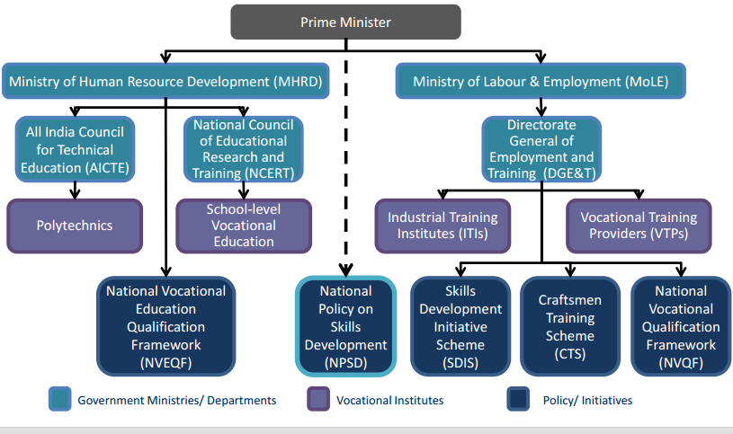

National policy on skill development

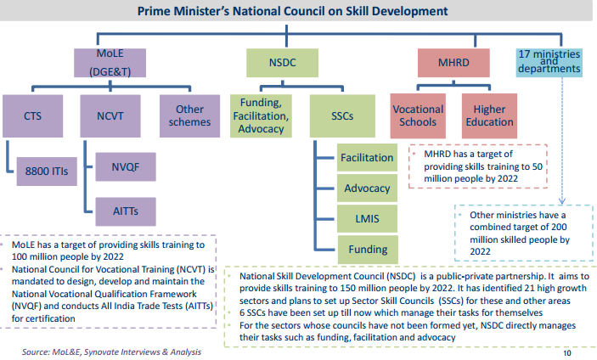

International Assistance for India’s Skill Development Programme

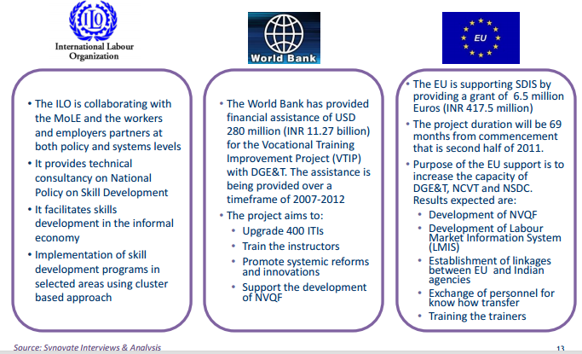

Even international bodies such as the International Labour organisation, World bank and European Union is providing financial assistance and consultative help to enhance skill development in the country. Apart from international bodies and other individual countries that are participating in the vocational education space in India ,private players have begun to play a role as well by starting commercial enterprises to impart vocational education in areas such as retail, finance, construction, fabrication etc.

3.3. Skill Development programs of Government of India
All the vocational training initiatives in the Union level are taken by the following departments. The most important are Ministries of Human Resource Development and Ministry of Labour and Employment are the key decision makers for Vocational Education and Training in India.
Ministry of Labour and Employment (MoLE) and Ministry of Human Resource Development (MHRD) are the two ministries formulating policies for the Vocational Education and Training (VET) sector in India. MHRD is assisted by the All India Council for Technical Education (AICTE) and National Council for Education Research and Training (NCERT) as highlighted: AICTE: Prepares curriculum and imparts vocational higher education through polytechnics .NCERT prepares curriculum and imparts vocational education at school level through open schools. The MoLE is assisted by Directorate General of Employment and Training (DGE&T) which imparts vocational training through Craftsmen Training Scheme (CTS) and Skills Development Initiative Scheme (SDIS)CTS. It provides training to 1.2 million people through Industrial Training Institutes (ITIs) and training to 1 million people through Vocational Training Providers (VTPs).Both the ministries are developing separate frameworks called National Vocational Qualification Framework .(NVQF) and National Vocational Educational Qualification Framework (NVEQF) for curriculum design, standardisation and certification.

National Policy on Skills Development (NPSD) is a Prime Minister’s initiative and is the main driver policy: It has set a target of providing skills training to 500 million people by 2022.The target has been divided between 20 ministries/departments/organizations. Under NPSD, National Skill Development Corporation (NSDC), a Public Private Partnership (PPP) has been set up to provide funding, facilitation and advocacy by means of 21 Sector Skill Councils (SSCs).All policies are framed at the Centre and implemented at state level by the state governments/departments.

3.4. Skill Development Programs of Government of Karnataka
All the vocational training initiatives in the State are taken by the following departments:
Department of Technical Education manages polytechnics and technical degree colleges.
Department of Employment and Training: The Department of Employment and Training implements National Employment Service Scheme and Vocational training schemes for unemployed youths as per the norms prescribed by DGET .Department of Vocational Education functions under Ministry of Primary and Secondary Education, Government of Karnataka and offers 29 trades through 500+ colleges providing 891 course units.
Karnataka Vocational Training and Skill Development Corporation implements the recommendations of National Skill Commission. National Skill Commission is established to address the gap due to lack of skills among unemployed youth and to facilitate under the State Policy on Skill Development.
A student can pick vocational courses from a variety of institutions: polytechnics, industrial training institutes (ITIs) and vocational courses at the PU level itself. There are 182 polytechnics (38 governments, 36 aided and 108 private institutions) offer diploma courses in various engineering disciplines, fashion technology, commercial practice, cinematography, etc. About 70,000 students are enrolled in these courses. The department of Vocational Education runs 890 courses as diverse and disparate as dairying, accountancy, garment design, civil construction and computer technology to name a few. There were 68 government and 328 private ITIs in the state in 1998-99, which increased to 104 and 466 by 2003-04, showing a growth rate of 8.9 per cent and 7.3 per cent per annum for government and private ITIs respectively. The enrolment in ITIs increased at a compound growth rate of 8.5 per cent per annum during the period 1998-99 to 2003-04. The enrolment in government institutions increased at 10.8 per cent while in private institutions it grew at 7.2 per cent per annum during the same period. Girls constitute only 16.6 per cent of all students and the enrolment of girls was about 2.5 times higher in south Karnataka than in north Karnataka (2003-04). Suresha. R and and B. C. Mylarappa / Journal of Continuing Education and Professional Development (2013) 1: 1-14 12

3.5. Karnataka Industry Overview
Industrially, Karnataka is one of the most advanced states in India. Known as the Silicon Valley of India, Bangalore is the IT hub. Two of the biggest firms internationally – Wipro and Infosys – are headquartered in the state. In fact, the Nandi Hills area near Devanahalli has upcoming the BAIL IT region which is one of the highest valued infrastructure projects which will give a renewed thrust to the sector. The state has also become the biotechnology capital for India. Biocon is headquartered in Bangalore and 158 of the 320 biotechnology companies in the country are present in the state. The economy of Karnataka is expected to gain fillip with several upcoming sectors. Auto and auto component, horticulture and processing, tourism and hospitality and textile are expected to provide employment to people across the state. As of 2011 - 2012, Karnataka had GSDP of Rs. 465,552 crore. There has been a nine per cent growth from the GSDP of Rs. 166,747 crore in 2004-05.

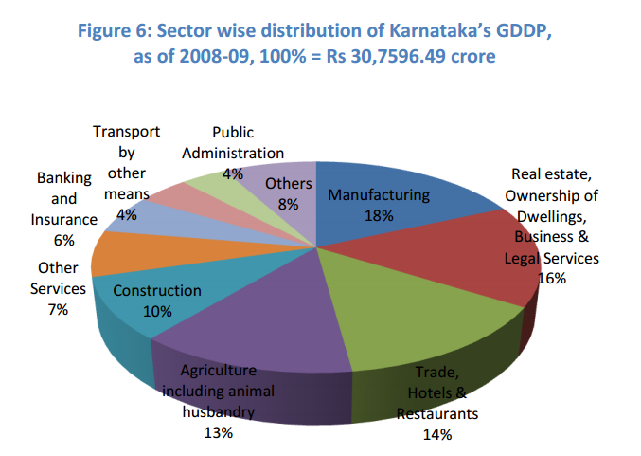
The state economy is pre-dominantly service based, with service sector’s share in GDDP at 53% in 2008-09. This is followed by secondary sector at 29% and primary sector at 18%. The detailed break-up of the three sectors is given above. From the classification of the single economic survey of Karnataka, the manufacturing sector is the largest single contributor to the states GDP.Karnataka ranks the second highest in the average number of employees engaged in factory related work on a daily basis. The total number of factories in Karnataka is 11782 and the total number of average daily employment was 1138.
3.6. Conclusion
There is effort put in both by the government of India and by the government of Karnataka to provide technical education and skill development to its people. There are a wide variety of courses and several providers. It provides skilled workers to the manufacturing sector of labour force. However it remains to be seen if it meets the growing need of skills and also the needs of the informal economy.

CHAPTER IV

WAGE DETERMINATION OF TECHNICALLY SKILLED WORKERS IN THE INFORMAL SECTOR

CHAPTER IV

WAGE DETERMINATION OF TECHNICALLY SKILLED WORKERS IN THE INFORMAL SECTOR
This chapter presents the findings of the empirical study that was carried out using a questionnaire. Since this study is exploratory and descriptive in nature, it was based on primary data.

4.1. Research Methodology
A questionnaire containing 40 questions was developed which was administered to workers engaged in technical trades under the supervision of the floor manage in the manufacturing sector in Bangalore urban district. Pilot study of 15 units was conducted and a total of 101 units was collected A schedule interview was done as many of the workers were not educated and hence could not read effectively.

Data was collected on individual attributes such as wages, work experience, ethnicity, schooling and other such details. The sample size was 100 from the unorganised sector engaged in technical trades from different parts of the industrial establishment in the city. The data was collected from sheet metal press workshops, printing workshops, lead lining factories, gas compressing factories and an automobile service shop. The sample was collected at random from the industrial area of the city and it is a representative sample in terms of the variables collected. There were 30 vocationally trained workers against the remaining 70 had undergone on the job training in the informal industrial sector.

The study had the objectives of examining the nature and extent of employment in the informal sector in terms of wages, mobility, and work experience and skill development. The second objective was to identify factors that determine wages in the technical trade in the informal sector by identifying factors that determine the wage rate of labourers such as trade engaged/specialised in, age, caste, and work experience.

The study analysed the data Statistical package for social sciences. Econometric tool namely ordinary least squared regression was used to determine the wages of workers engaged in the manufacturing sector. Besides it used descriptive statistics to show the relationship between different variables by creating cross tabulations. Appropriate presentation of the findings is done using charts, tables and flow charts imported from Microsoft excel.
Hypotheses
Ho: There is no wage difference among informal technically skilled workers on the basis of Educational Qualification
H1: There is wage difference among informal technically skilled workers on the basis of Educational Qualification

4.2. Data Source
The study has identified the following variables for analysis:
Wages: this is the dependent variables regressing all other collected variables on wages to identify the most significant influence of these variables on wages. The wages used are current wages as replied by the workers and the supervisor. Wages have also been collected of their previous employment to determine the growth of these wages.

Ages: the population is working age between 17 and 60.There is a large group of people between the ages of 20-30 which is a representative of India’s demographic dividend. The age subtracted from the number of years of work gives rise to the variables starting age of work which is necessary to find the reduction of child labour in India.

Years of work: is an important variable as regression analysis is used to check the significance of work experience on wages. It was calculated using the employment history of the worker such number of job changed and tenure in each job.

Educational level: the education level has been divided into 3 groups for the regression analysis ie. vocationally trained, SSLC and PUC and SSLC and SSLC and below. However for the purpose of cross tabulation education classes were divided into illiterate, midde school, high school, SSLC, PUC and vocationally trained.

Nature of trade: as the firms in the sample high casual labour who are given on the job training they are skilled in various jobs around the factory and are known as “helpers” which is the majority of the population. Other positions on the shop floor include welder, machinists, turners, fitters and other trades.
Nativity: the place of birth is important as it denotes the migratory status of workers whether thy are from the state, outside the state or are localities originating from Bangalore urban or rural. Analyses can be done on the wage differential between migrants of the 3 classes.

Nature of school (government or private):it is seen that mostly urban background workers have studied in government school and more urban backgrounded workers’ have studied in private schools.
No of jobs changed: the respondents have replied based on their perception of formal employment therefore years spent doing odd jobs or farming are not included. It provides a crude work history.

Whether inclined to entrepreneurship: this question was asked in the end to see if workers are willing or interested in starting new businesses. This was a sensitive question as many workers had never been asked this. The response was slightly ambiguous but inferences can be made from this variable.

4.3. Empirical Results in Descriptive statistics
This section presents a description of the variables used in t he study.

Frequency Distribution of Age

The frequency distribution of age was converted into a discreet series with a class size of 10 years. The sample shows the highest concentration of workers aged in the age class 20-30 years of age. The first class size is less than 20 years in which there are very few respondents showing the decline of child labour in this sector due to the nature of work. The nature of work involved heavy machinery and moving parts thus employing lesser minors.
Chart 4.1. Distribution of Respondents By Age
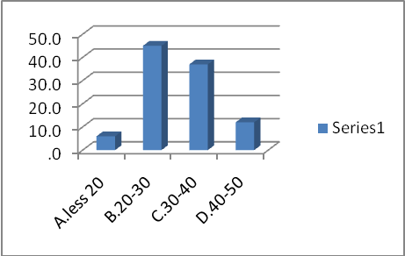

Source: collated from field work

Chart 4.2. Distribution of Languages Spoken by Industrial Workers
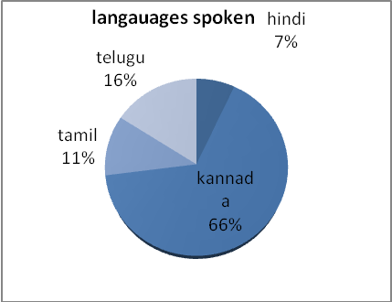
Source: collated from field work

The chart shows that the language composition of the sample can be divided into 4 categories based on the most common languages among the respondents. As the sample was collected from various factories around Bangalore 66% of the employees speak Kannada and the second most common language is Telugu which shows the states interest in entering technical related fields. Andhra people have been known to be attracted to such forms of employment.
Nativity Distribution
The original data included the district where the respondent was born and pursued their education. The districts were then recategorised to show those whose native is from around areas close to Bangalore labelled as “local”. The local category includes predominantly rural dwelling that have now become urbanised. The numbers of such local employees is lesser than expected Around 28% meaning only a fifth of the entire sample are from Bangalore and most have migrated from elsewhere. 5% of the samples have origins within the state but not within the district. This category has been labelled as "same state". This leaves only 14% of the sample originating from an area outside of Karnataka. Therefore most informal labour is within the states meaning it has to be managed by the state legislature and not central legislature. This could be true for labour in other states as well. This is shown in the following chart.

Chart 4.3. Distribution of Respondents by Nativity

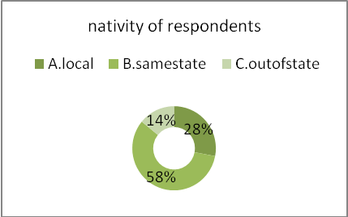
Source: collated from field work

Chart 4.4. Education Qualification and Wage Groups
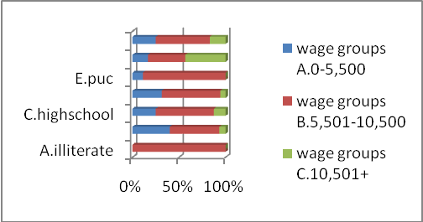

Source: collated from field work

Educational qualification of respondents has been collected during the survey to check for wage differences for labourers with varying educational qualifications. The educational qualification has been divided into 6 categories and income has been categorised into 3 categories. The cross table computed by SPPS shows the largest number of labourers who earn wages in the high income group greater than 10,501 are also vocationally trained. Showing that those who are vocationally trained earn higher wages this is due to the difference of the nature of employment in the formal and informal sector. However there are an equal number of labourers who are vocationally trained but earn wages in the middle income group. There is a wage difference for those labourers who have not cleared the SSLC.As the majority of the sample falls into the second category of income ie.5501-10500 even those who have not been educated will therefore fall into this category, this is evident by looking at the income groups the illiterate labourer fall into which is the middle groups. Conclusions can be made by observing how many labourers fall into the other two categories. Those who are illiterate do not get high income salaries but nor do they get low income salaries either, therefore no conclusion can be made yet. In the second class of educational qualification ie. middle school, labourers fall into both income categories middle income and lower income but not in the higher income categories. This trend is becomes more evident with subsequent educational classes until the final educational classes "formal vocational training". In the final category of education the distribution is not normal as before, here the largest number of formally trained workers fall into the higher income category.

Chart 4.5. Trade Distribution

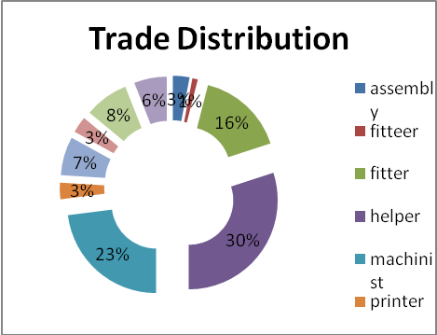
Source: collated from field work

The chart shows the number of workers engaged in each trade. Due to the informal nature of the sector, the trades mentioned are not absolute as many workers have are skilled in multiple trade therefore only the current trade has been used to make this frequency distribution. The trade with the highest number of workers from the 100 sample set is "helper". Contrarily to popular belief the multiskilled worker appears to be more vital to the firm than the skilled welder or fitter. This conclusion may be due to the nature of the sample which is not collected industry wise but it is a representative as four factories engaged in different work was sampled. In all the factories the helper was the most common worker showing the importance of multiskilled workers. These helpers are skilled in basic machinery, human resources,logistics and finance.

Chart 4.6 Number Of Workers and Their Work Experience
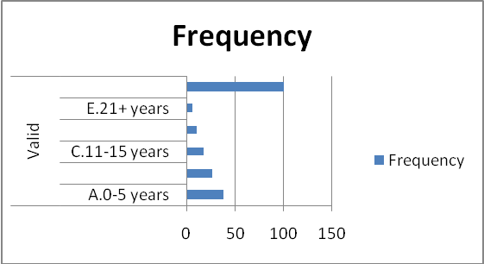
Source: collated from field work

A study on the mobility and wages of informal workers requires data on their work experience which has been collected for all samples. As this is a variable that has low variance across industries it can be taken as a good representative of informal workers. The data shows that 38% of workers are still in the initial stages of their career in the informal industry with 0-5 years of work experience.
Chart 4.7. Work Experience and number of Jobs changed

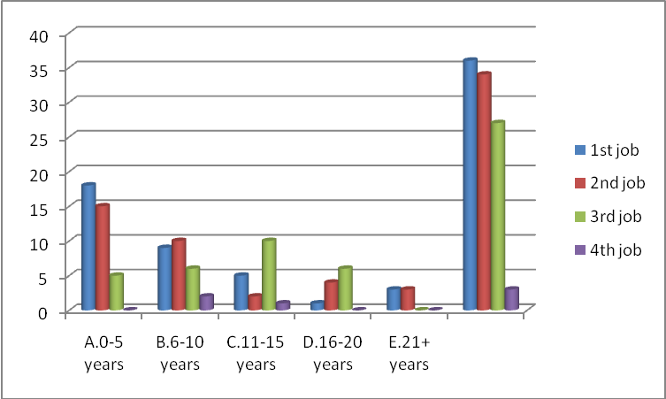
Source: collated from field work

The previous chart showed age and job mobility to illustrate the changing demography, marital influence and increased employment opportunity. This table is a cross tabulation of work mobility and work experience. Work experience includes any form of employment the respondent felt was his first real job. The workers may have had other odd jobs but the number of jobs they said they had changed were jobs they considered to be formal employment.
Chart 4. 8. Wage Distribution among respondents
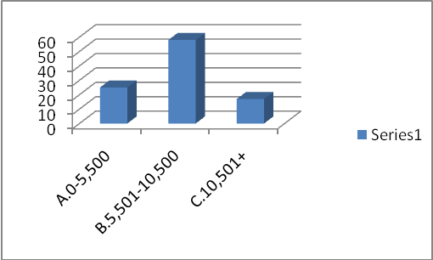

Source: collated from field work

The wage data collected has been categorised into 3 classes. Each class interval size is Rs.5550 per month at their current jobs. The graph shows a normal distribution of wages with 58% of the workers fitting into the middle income group earning wages between Rs.5501-10500.
Table 4. 1.Cross Tabulation between Age and Number of Jobs Changed
Age group | no.job changed |  |  | Total
Age group | 1 | 2 |  | 1
A.less 20 | 2.00 (33) | 4.00 (67) | A.less 20 | 2.00 (33)
B.20-30 | 20.00(44) | 13.00 (29) | B.20-30 | 20.00(44)
C.30-40 | 9.00(24) | 15.00 (41) | C.30-40 | 9.00(24)
D.40-50 | 5.00(42) | 2.00 (17) | D.40-50 | 5.00(42)
Source: collated from field work
Chart 4.8. Age and Number of Jobs Changed

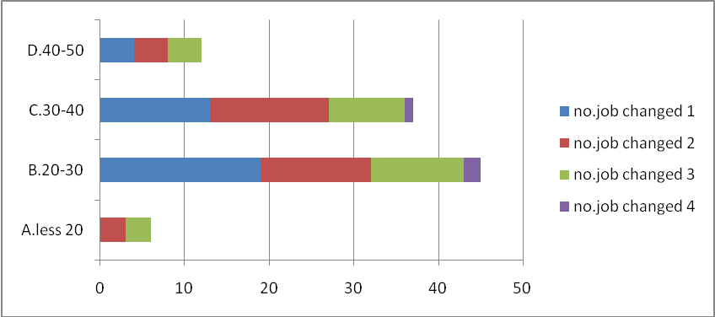

This is a cross tabulation between ages and work experience to illustrate the most frequent age after which a worker changes his job. In the first age group 33% are still in their first job and 67% of them are in their second. This shows again that young workers are more mobile and such mobility will be a trend that will be followed in future.44% of workers between the ages 20-30 are still in their first job and the number of workers who have entered the second, third and fourth job is decreasing. The age group which highlights the significance of worker mobility is the third group between the ages of 30-40.Only 24% of these workers are still in their first job and 41% of them have moved on to their second job at least however none of them are in their fourth job and this is seen as the limit of mobility in the informal sector for technical trades. An irregular figure is seen with the age groups between 40-50.Here there are an equal number of workers in their first and third job. This may be due familial obligations.

Table 4.2. Wages and Tradewise

Chart 4.9.Wages and Tradewise
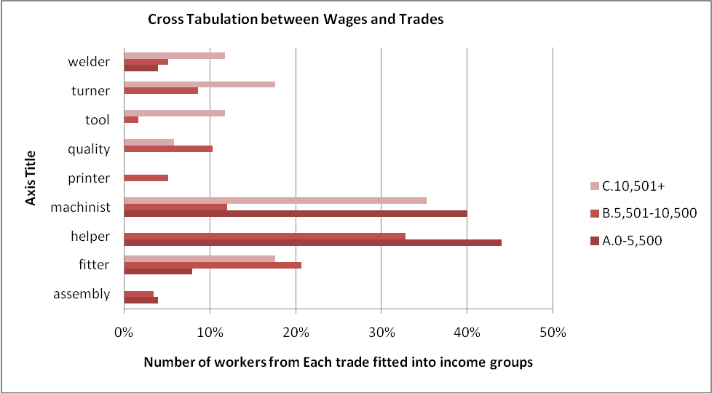
Source: collated from field work

4.10. Entrepreneurial Tendencies Education Qualification dependent

Education qualification | Yes | No | Total
A.illiterate | 3 | 0 | 3
B.middleschool | 11 | 4 | 15
C.highschool | 7 | 1 | 8
D.sslc | 34 | 1 | 35
E.puc | 5 | 4 | 9
Ug | 15 | 15 | 30
 | 75 | 25 | 100

Chart 4.10 Entrepreneurial Tendencies Education Qualification dependent
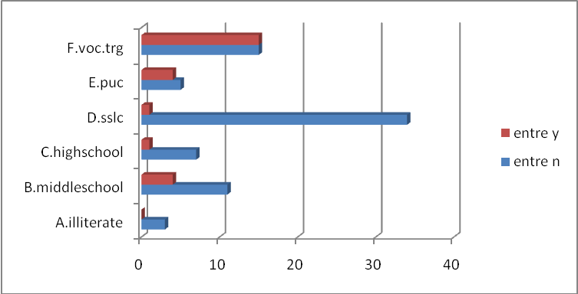
Source: collated from field work

For the personal benefit of the researcher data was also collected to check the entrepreneurial inclination of industrial labourers. The final question in the Questionaire asked respondents weather rhey would be interested in starting their own business one day.The respondents have never been asked that question and replied under the guidance of the floor manager who indicated a negative. However 25% of the respondents did want to start their own business.Those who were inclined to start their own business were more likely to be formally trained at an ITI or ITC.This is an important statistic as India will remain informal for a long time and informal workers must be given jobs by such entrepreneurs.

Chart 4.11 Educational Qualification and Mobility
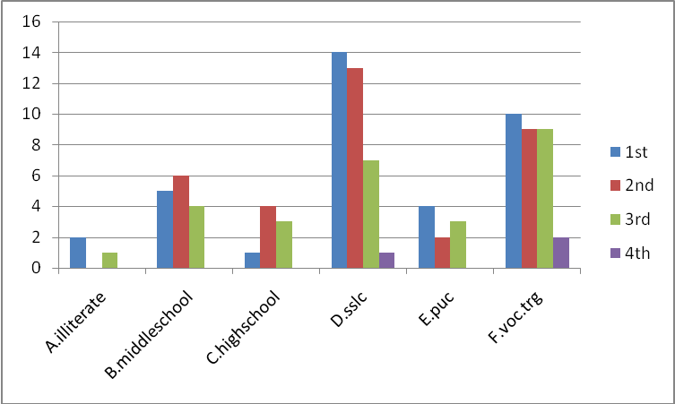

From the given data it is observed that illiterates were happy to find a job and have remained in that job with almost no mobility on the other hand all vocationally trained workers are seen to have been spread out to work in various factories during their career.Most SSLC pass students are either between their first or second job but there are almost an equal number of vocationally trained workers who are in their first,second or third job.This shows that vocationally trained workers are more mobile and therefore are much more experienced.

4.2. Econometric Analysis
In order to determine the impact of Age, Caste, marital status, nativity and formal vocational training on wages, so linear regression analysis was performed. The linear regression have been performed on the entire data set of 100 respondents.

6.4.Econometric Results
Model Summary
Model |  | R | R Square | Adjusted R Square | Std. Error of the Estimate
 | 1 | .447 | .200 | .166 | 4080.291

Source: Collated from field work
From the tabulation table the results of multiple regression analysis, where demographic variables (Independent variables) are regressed against the wages (dependent variables). The R Square is about 0.447 and adjusted R square is about 0.200. Therefore the model can explain 16% variation in dependent variable that is wages due to change in independent variables. So 84% variance is caused by the other factors which are not included in the study.

Table 4.3. Linear Regression of Independent Variables on Wages

Coefficientsª
Model |  | Unstandardized Coefficients |  | Standardized Coefficients | T | Sig.
 |  | B | Std. Error | Beta | T | Sig.
1 | (Constant) | 5682.271 | 1441.040 |  | 3.943 | .000
1 | general=1 | 425.128 | 1047.441 | .048 | .406 | .686
1 | voc.trg | 4280.899 | 1142.310 | .441 | 3.748 | .000
1 | work_xp | 76.484 | 50.381 | .140 | 1.518 | .132
1 | male | 400.274 | 1277.076 | .029 | .313 | .755
a. Dependent Variable: current_wage

CHAPTER V

SUMMARY,CONCLUSION AND POLICY IMPLICATIONS

Summary

The study on informal workers in the manufacturing sector in and around Bangalore has shed light on various aspects of labour pertaining to their wages, work history, nativity, mobility, educational qualifications and entrepreneurial aspirations. From the data much was revealed regarding the differences in wages across different educational qualifications. The largest wage difference is seen for workers who have undergone formal vocational training when compared to workers who have received only on the job training. More vocationally trained workers were more likely to fall into the higher income group of workers. It was also seen that as the education level of worker was higher their mobility also increased indicating a strong relationship between education and mobility.
It was seen that more than 50% of the workers labelled themselves as “Helper” in the factory. These helpers are engaged in almost all tasks ranging from Leth operation, Logistics, Human Resources and Accounting. This is contradictory to conventional belief that factories are run by vocationally trained workers they are apparently run by “helpers” who are in some crude form a manager.
An additional question was asked to the respondents: “.Will you start your own business one day?”
75% of the workers said they would not and the remaining 25% said they would. Those who were willing to start their own business were the most educated passing PUC or undergone Vocational Training.

Conclusion
The informal sector which employs a large number of people is usually related to characteristics of workers who work in precarious labour market conditions which include lack of access to labour protection and social cover and hence have low quality of employment. The levels of skills required for employment in this sector is low and often acquired while on the job. The shortfall in skill arise from the fact that it is most often due to low education of prospective workers, unequal access to training, underdeveloped markets, lack of attention by public training providers, and market constraints affecting small and household enterprises. A large number of the workforce in India and in several other developing countries is engaged for work in this informal sector.

Policy implications
Socio Economic variables of the workers showed that more than 50% of the workers were from Karnataka implying that informality of the work force is a state issue to be handled by the state legislature. This can be done by increasing the number of ITI colleges and advertising its career prospects.
The educational break-up of the workers and their mobility shows that workers who have not studied at the beginning of their lives are still unable to rise to a higher level regardless of the years of work experience.
The Labour structure of the factories show that 50% of the workers are “helpers” this means they are very crucial members of a factory who perform all tasks related to running the factory. Thus it is in the Output. This can be done by making MBA programmes more affordable and accessible to such workers.
As the work experience of the worker shows no significance to their wages and education shows a positive relationship it is necessary for workers to be educated to raise their standard of living. However many of these workers have not studied to overcome this problem the state should issue certificates validating their work experience and skill to increase their value in the market.
The Entrepreneurial inclination of informal workers is low but it exists nevertheless among the educated workers. It is in the interest of the state to promote the idea of Entrepreneurship at the school and college level. By promoting the idea of entrepreneurship in ITI’s industrial workers will work towards building an industry of their own which will continue providing employment to unskilled workers.
The informal sector provides mass employment to those who would otherwise never gain employment. The informal labour scenario in India cannot be changed overnight and must be accepted as a way of the economy’s functioning.
Having accepted formalising India’s industrial workers as a long term goal.Policy must be drafted two fold
1. Formalise as many workers as possible by issuing certificates
2. Provide Entrepreneurship training to those enrolled in Vocational courses so that they may start their own business one day and continue employing unskilled workers.

REFERENCES

Ajaya Kumar Naik,2009,“Measuring the Informal Economy in Developing Countries".
Adams,2013, "Improving Skill Development In Informal Sector In Subsaharan Africa"

Adams,2008,"Skill Development Informal Sector Subsaharan Africa

Aydın, Hisarcıklılar and İlkkaracan(2007)" The Returns to Education in Formal and Informal sector"

Labour Bereau,2011, Labour Report

Leontaridi (1998). "Segmented Labour Market: Theory and Evidence ".
Losby.J. L. (2003). "The Informal Economy: Experiences of African Americans."
National Statistics Commission,2012, Report on the Committeee of the Unorganised Sector

Planning Commission,2012, Manufacturing Plan 2012 and Beyond

Shonchoy, A. (2013). "The Informal Labour Market in India:Transitory or Permanent Employment for Migrants?"

Smith,2013, Informal and Non Standard Employment in The US
Suresha.R and B. C. Mylarappa,2012, Literacy and Education System in Karnataka State
Tansel and Kan(2012)

Unesco,2011,Building Skills in Informal Sector.

Unni and Rani (2005)

Ralf Hussmanns "Defining and measuring informal employment"

ANNEXURE-I
QUESTIONNAIRE

 | Age
 | Sex |  | - Male 2.Female
 | Religion 1.Hindu 2. Muslim 3.Christian 4. Others
 | Mother tongue
 | Place of birth
 | Caste. Choose one 1.SC 2. ST 3.OBC 4. GENERAL
 | Marital status |  |  | - Single 2.Married
 | Educational qualification
 | Medium of instruction in school
 | Year of passing out from school
 | School District |  |  |  | Rural or Urban |  |  | Private/ govt
 | Institute District |  |  |  | Rural or Urban |  |  | Private/ govt
 | Name of the vocational course undergone
 | Year of passing out from institute
 | Course duration in months or years
 | Course fee
 | Source of funding1.Family money 2.Earnings3. Bank loan4.Scholarship
 | Duration of on the job training/apprenticeship in first job
 | Stipend/pay during training if any
 | How many jobs did you change till now?
 | Names of other industries worked in
 | When did you get your first job
 | What was your post first job?
 | How long did you stay in your first job?
 | Wage in first job
 | What was your post in second job?
 | How long did you stay in your second job?
 | Wage in second job
 | How long have you been in current job
 | Wage in current job
 | Current Post
 | Will you start your own business one day? |  |  |  |  |  | - YES 2.NO

ANNEXURE-II
TABLES

Chart 4.1. Distribution of Respondents By Age
age_int
 |  | Percent
Valid | A.less 20 | 6.0
Valid | B.20-30 | 45.0
Valid | C.30-40 | 37.0
Valid | D.40-50 | 12.0
Valid | Total | 100.0

Chart 4.2. Distribution of Languages Spoken by Industrial Workers
mother.T
 |  | Percent
Valid | hindi | 7.0
Valid | kannada | 66.0
Valid | tamil | 11.0
Valid | telugu | 16.0
Valid | Total | 100.0

Chart 4.3. Distribution of Respondents by Nativity
birth_plc
 |  | Percent
Valid | A.local | 28.0
Valid | B.samestate | 58.0
Valid | C.outofstate | 14.0
Valid | Total | 100.0

Chart 4.4. Education Qualification and Wage Groups
edu.qln * curwage_int Crosstabulation
Count
 |  | wage groups |  |  | Total
 |  | A.0-5,500 | B.5,501-10,500 | C.10,501+
edu.qln | A.illiterate | 0 | 3 | 0 | 3
 | B.middleschool | 6 | 8 | 1 | 15
 | C.highschool | 2 | 5 | 1 | 8
 | D.sslc | 11 | 22 | 2 | 35
 | E.puc | 1 | 8 | 0 | 9
 | F.voc.trg | 5 | 12 | 13 | 30
Total |  | 25 | 58 | 17 | 100

Chart 4.5. Trade Distribution
trade
 |  | Frequency
Valid | assembly | 3
Valid | fitteer | 1
Valid | fitter | 16
Valid | helper | 30
Valid | machinist | 23
Valid | printer | 3
Valid | quality | 7
Valid | tool | 3
Valid | turner | 8
Valid | welder | 6
Valid | Total | 100

Chart 4.6 Number Of Workers and Their Work Experience
work_xp_int
 |  | Frequency
Valid | A.0-5 years | 38
Valid | B.6-10 years | 27
Valid | C.11-15 years | 18
Valid | D.16-20 years | 11
Valid | E.21+ years | 6
Valid | Total | 100

Chart 4.7. Work Experience and number of Jobs changed
 |  | no.job changed |  |  |  | Total
 |  | 1st job | 2nd job | 3rd job | 4th job
work_xp_int | A.0-5 years | 18 | 15 | 5 | 0 | 38
 | B.6-10 years | 9 | 10 | 6 | 2 | 27
 | C.11-15 years | 5 | 2 | 10 | 1 | 18
 | D.16-20 years | 1 | 4 | 6 | 0 | 11
 | E.21+ years | 3 | 3 | 0 | 0 | 6
Total |  | 36 | 34 | 27 | 3 | 100

Chart 4. 8. Wage Distribution among respondents
curwage_int
 |  | Frequency
Valid | A.0-5,500 | 25
 | B.5,501-10,500 | 58
 | C.10,501+ | 17
 | Total | 100

Table 4. 1.Cross Tabulation between Age and Number of Jobs Changed
Age group | no.job changed |  |  | Total
Age group | 1 | 2 |  | 1
A.less 20 | 2.00 (33) | 4.00 (67) | A.less 20 | 2.00 (33)
B.20-30 | 20.00(44) | 13.00 (29) | B.20-30 | 20.00(44)
C.30-40 | 9.00(24) | 15.00 (41) | C.30-40 | 9.00(24)
D.40-50 | 5.00(42) | 2.00 (17) | D.40-50 | 5.00(42)

Chart 4.8. Age and Number of Jobs Changed
age_int * no.job changed Crosstabulation
 |  |  | no.job changed |  |  |  | Total
 |  |  | 1 | 2 | 3 | 4 | Total
age_int | A.less 20 | Count | 2.00 | 4.00 | - | - | 6.00
age_int | A.less 20 | % within age_int | 33% | 67% | 0% | 0% | 100%
age_int | B.20-30 | Count | 20.00 | 13.00 | 9.00 | 3.00 | 45.00
age_int | B.20-30 | % within age_int | 44% | 29% | 20% | 7% | 100%
age_int | C.30-40 | Count | 9.00 | 15.00 | 13.00 | - | 37.00
age_int | C.30-40 | % within age_int | 24% | 41% | 35% | 0% | 100%
age_int | D.40-50 | Count | 5.00 | 2.00 | 5.00 | - | 12.00
age_int | D.40-50 | % within age_int | 42% | 17% | 42% | 0% | 100%
Total |  | Count | 36.00 | 34.00 | 27.00 | 3.00 | 100.00
 |  | % within age_int | 36% | 34% | 27% | 3% | 100%

Table 4.2. Wages and Tradewise
Trade | Wages |  |  | Total
 | 0-5,500 | 5,501-10,500 | 10,501+
assembly | 4% | 3% | 0% | 3%
fitter | 8% | 21% | 18% | 17%
helper | 44% | 33% | 0% | 30%
machinist | 40% | 12% | 35% | 23%
printer | 0% | 5% | 0% | 3%
quality | 0% | 10% | 6% | 7%
tool | 0% | 2% | 12% | 3%
turner | 0% | 9% | 18% | 8%
welder | 4% | 5% | 12% | 6%
 | 100% | 100% | 100% | 100%

4.10. Entrepreneurial Tendencies Education Qualification dependent

Education qualification | Yes | No | Total
A.illiterate | 3 | 0 | 3
B.middleschool | 11 | 4 | 15
C.highschool | 7 | 1 | 8
D.sslc | 34 | 1 | 35
E.puc | 5 | 4 | 9
Ug | 15 | 15 | 30
 | 75 | 25 | 100

Chart 4.10 Entrepreneurial Tendencies Education Qualification dependent
edu.qln*entreCrosstabulation
 |  | entre |  | Total
 |  | n | y
edu.qln | A.illiterate | 3 | 0 | 3
 | B.middleschool | 11 | 4 | 15
 | C.highschool | 7 | 1 | 8
 | D.sslc | 34 | 1 | 35
 | E.puc | 5 | 4 | 9
 | F.voc.trg | 15 | 15 | 30
Total |  | 75 | 25 | 100

Chart 4.11 Educational Qualification and Mobility
edu.qln |  | no.jobchanged |  |  |  | Total
 |  | 1st | 2nd | 3rd | 4th
 | A.illiterate | 2 | 0 | 1 | 0 | 3
 | B.middleschool | 5 | 6 | 4 | 0 | 15
 | C.highschool | 1 | 4 | 3 | 0 | 8
 | D.sslc | 14 | 13 | 7 | 1 | 35
 | E.puc | 4 | 2 | 3 | 0 | 9
 | F.voc.trg | 10 | 9 | 9 | 2 | 30
Total |  | 36 | 34 | 27 | 3 | 100

